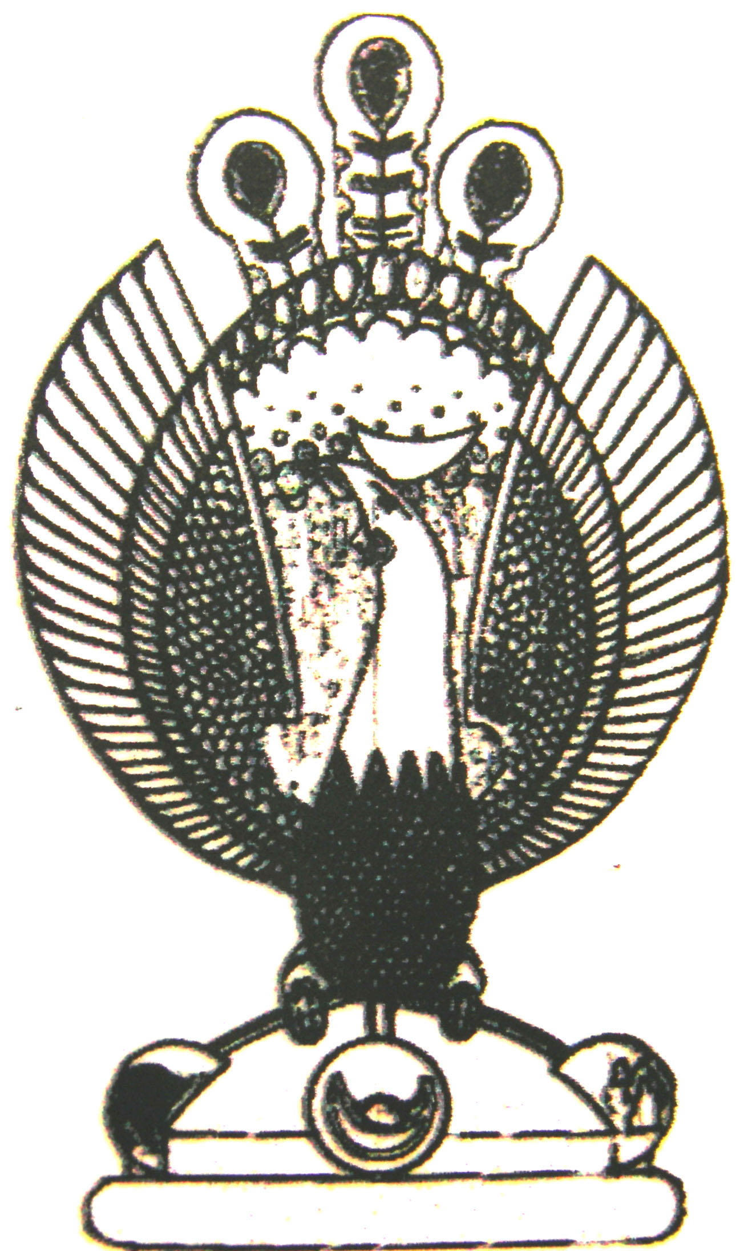

THE HERITAGE

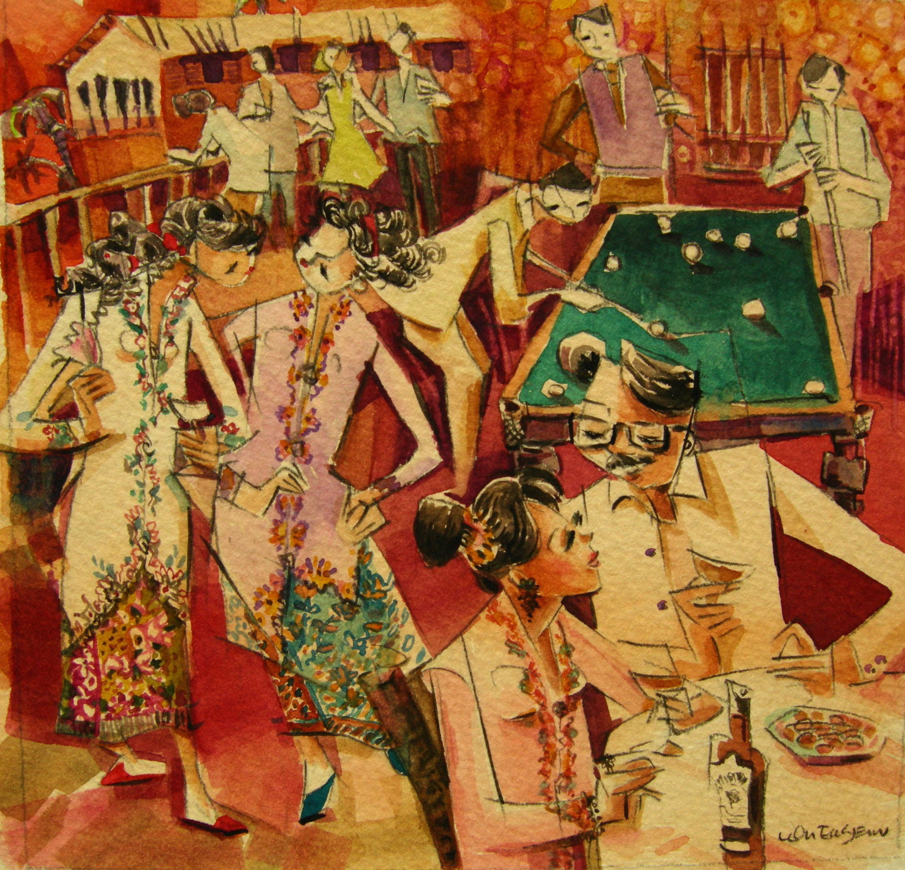
Clubs
Joining a club or an association give the peranakans a certain standing in the society.

